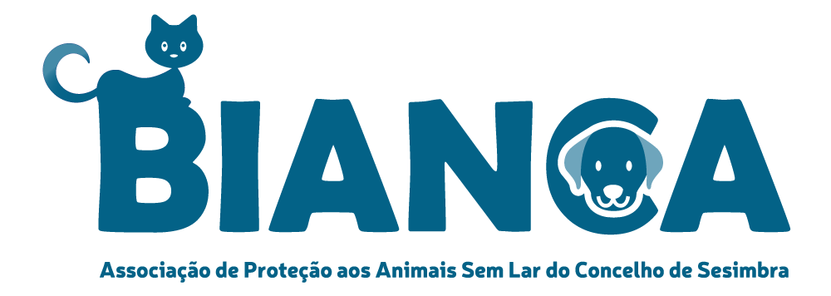
ADOPTION AGREEMENT

This agreement is subject to the conditions set out below that were thoroughly discussed, explained and accepted beforehand by the parties.

The following parties:

- Bianca Associação, Help with adoption Portuguese stray dogs..
Adres GPS Coordinates: LAT 38.488893 LNG - 9.122654 www.bianca.pt of www.bianca.pt/english

And

- Mr./Mrs referred as ‘Adopter’

Street and housenumber:
Postal code: City:
Telephone: Mobile: + Date of birth:
Email address:

Come across the following dog:
Name: New name: Here after referred to as ‘the dog’
Gender: male/female Breed: Mix Date of birth:
Color: Coat:
Castrated/sterilized: Yes/No
Comments:___________________________________________________________________________________
As adoption support, the adopter makes a donation of € 365,-- all in without additional costs.
The amount of the fee must be paid 2 weeks before the planned flightdate.
When making a reservation we ask € 50,-- for planning of the flight after the intake/homevisit. This will be .
Compensated with the adoption fee
NL55 INGB 0798981628 tnv. J. Lageveen ovv naam hond.

Considering that:

- Bianca Associação is a recognized non-profit foundation, where volunteers are committed to saving battered or dumped (stray) dogs in Portugal, from the streets, and giving them the opportunity to live a good life through adoption. Bianca Associação dedicates herself to better legislation, implementation and control on the ground, sets up castration programs and provides education about animal welfare;
- The dogs that Bianca Associação offers for adoption are rescue dogs who are in an asylum so that Bianca Associação can’t guarantee a perfect dog and thus there is an obligation of means on Bianca Associação;
- Deviation from this agreement is only possible subject to prior written agreement of both parties.

The following:

- Adopter undertakes to provide the dog in a sustainable manner in accordance with the legislation on animal welfare and animal protection of the adoptive country and thus give sufficient exercise according to race and age, sufficient good nutrition and good housing to include: always stay overnight, not be put on a chain and not kept in a kennel or other (closed) facility.
- Adopter must not cause the dog to undergo deliberate mutilation. Adopter will have the dog vaccinated in accordance with the current regulations and, in case of illness of the dog, ensure appropriate veterinary treatment.
- The dog may not be used for commercial purposes, including breeding. If a pregnancy does occur.
- Bianca Associação provides the dog with a European animal passport and a chip. In the event of a change of address, Adopter will have the chip registration adjusted to the competent (government) service within three days and will notify Bianca Associação of its new address.
- Bianca Associação mentions in the passport the administered vaccinations, given according to the internationally recommended. Vaccination schedule (rabies, distemper, hepatitis and parvo, supplemented with parainfluenza and Weil's disease). When the dog leaves Portugal for Adoptant, Bianca Associação takes care of it, even before a final anti-parasitic treatment.
- Bianca Associação will testively test every dog from the age of six months on babesiose, ehrlichia, leishmania en dirofilary (heartworm). Adoptant accepts that the results of these tests are necessarily a snapshot and do not guarantee the future. Bianca Associação ensures the most accurate and fair description of the state of health prior to adoption.
- The character, appearance and history of the dog as far as known. Adopter accepts that this description can’t be conclusive and/or complete, owing to the fact that the dog is a living being and stays in a shelter or foster family for the transfer, so that Bianca Associação can’t give any guarantees for the future. Adoptant can request additional information and photos.
- Bianca Associação will hand over the dog to Adopter in the best possible condition. Given the stay in a shelter or foster family, the journey and change of environment, food, etc., caused stress by which the dog's immune system can be affected, Adopter accepts that the dog can develop cough, (ear) mite and / or diarrhea .
- Bianca Associação transfers the dog neutered unless this intervention could not be carried out for reasons, in which case Adopter must have this operation carried out at his expense within six months after transfer. Puppies should be neutralised at their own expense at a later appropriate time.
- Bianca Associação can’t be held responsible if, for reasons beyond her control, the dog is transferred at a different time and/or location than agreed.
- If the dog demonstrably dies, by a written motivated statement from a veterinarian, within 30 days after transfer as a result of a pre-existing but not previously known by Bianca Associação, Adoptant may, choose another dog or get 50% refund of his contribution paid in advance.
- Adopter expressly agrees to give the dog the necessary rest after transfer so that the dog can get used to the new environment, people and animals. To this end Adoptant will give the dog minimum three months adjustment time.
- After transfer Adopter guarantees all possible damage caused to or by the dog, irrespective of the cause, as well as all expenses incurred for the dog, including the (urgent and necessary) medical costs.
- Adopter must take the necessary measures to avoid losing the dog and to avoid missing persons.
- Adopter informs Bianca Associação if the dog has died.
- Bianca Associação asks Adopter to give her now and then pictures and updates of the dog. Adopter gives Bianca Associação express permission to publish this.
- If the dog can no longer stay with Adopter, Bianca Associação will look for a temporary shelter and a good new adopter. Adopter gives Bianca Associação at least fourteen days after receipt of the required waiver. Adopter will continue to take care of the dog in accordance with this agreement until the dog is transferred to Bianca Associação. There is no refund of the paid contribution. Adoptant may in no case transfer the dog to third parties or to a shelter.
- In the event of non-compliance with this agreement, Bianca Associação has the right to reclaim the dog without prior notice of.
- Bianca Associação respects your privacy. By signing this contract, Adopter agrees that Bianca Associação will process its personal data in a file that will only be used for legitimate purposes within the international framework within which Bianca Associação operates, including the use in connection with the execution of this agreement. The personal data of Adopter are not communicated to third parties nor commercialized, unless Adopter gives permission for this. In the event that the adopted dog is financially supported by a virtual adopter, Adopter gives permission to give his contact details to the virtual adopter for a non-binding contact.
- Anny comments:
_____________________________________________________________________________________________________
_____________________________________________________________________________________________________
Bianca Associaçãois can always use help and donations for the shelter and the dogs.

Chipregistration

The Adopter, in accordance with the legal provisions, is responsible for the timely chip registration in its name and address with the competent (goverment)service.

1. Adoption shall be final only after Bianca Associação has received the contract properly completed and signed.
2. In addition, the adoption amount must have been transferred 2 weeks before the planned flight to an account number:

NL55 INGB 0798981628 tnv. J. Lageveen ovv naam hond.

Drawn up in duplicate, 1 copy in Dutch for Adoptant and 1 copy in English for Bianca Associação

place__________________________________________ date ______________________________________which each party acknowledges having received a copy.

“read and approved”  Signature adopter(s) | Signature volunteer Bianca Associação
Name: | Name: Coby Lageveen

+31(0)6-42384341

Page 3 of 3

