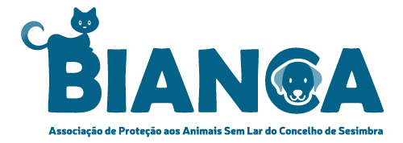
Adoptioncontract cats/kittens

By signing this purchase contract, the adoptant and Bianca associação of the cat/kitten to which this purchase contract relates declare to agree to all the provisions in this purchase contract. This contract of adoption is therefore binding on both parties.

Cat data:
Name: Breed:
Colour: Day of birth ±:
Gender: Chipnumber (see passport):
Neutralized: yes / no

adopter:
Name: Adress:
PC + City: Phonenumber:
E-mail: Mobile nr.

Payment: The adoption fee of a cat is € 275,-.
After signing the contract we ask for a deposit of € 50,- to plan the flight.
Full payment must be made before departure if the flight date is known. You can deduct the prepayment from this payment.
NL55 INGB 0798981628 in the name of. J. Lageveen with the name of cat/kitten.

- Bianca associação hereby declares that at the time of sale the above cat/kittens to the best of its knowledge and after examination by the veterinarian, completely healthy and free of diseases, abnormalities and any parasites and/or skin conditions Bianca associação declares that the cat has given all necessary care and attention, which the cat needs to grow into a healthy and social cat.
- Bianca associação declares that she has given the cat the necessary vaccinations and worming treatments. Adopter receives the vaccination booklet upon transfer. (European passport) cats have been tested for FIV, FeLV,
- Adopter declares to give the purchased cat a loving home. Adopter declares that the cat:
- is freely housed in a home, not locked in a cage or other small secluded spaces;
- will not be deprived of human company and domestic movement;
- will receive healthy, mixed cat food;
- will receive good, hygienic care;
- will receive responsible medical assistance if necessary.

- If the adopter wishes to re-place the cat, the adopter is obliged to return the cat to Bianca associação. The adopter agrees never to resell or give the cat to third parties, and never to place the cat in a shelter!
If the cat has to fly back to Portugal the cost for a ticket has to pay by the adoptant.
- The cat may not be bred, adopter is aware of this. Non-neutralized kittens must be neutered within 1 year, costs are for the adopter.
- All legal costs arising from the violation of the provisions and agreements contained in this purchase contract shall be for the account of the adopter.

City: Date:

On behalf of Bianca associação
Signature: Signature adopter:
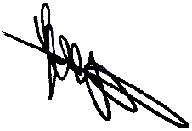

Name: Coby Lageveen Name:

+31(0)642384341

